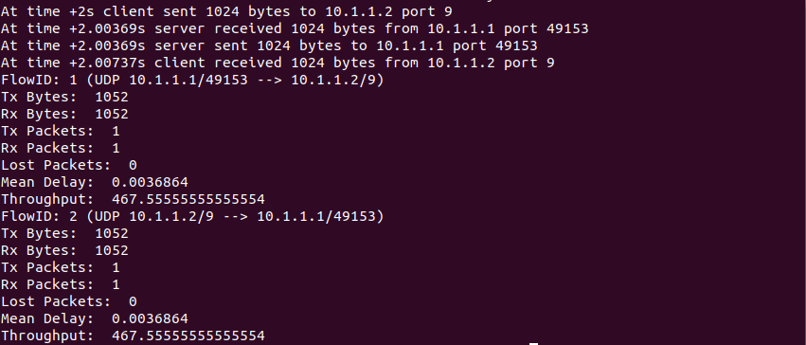

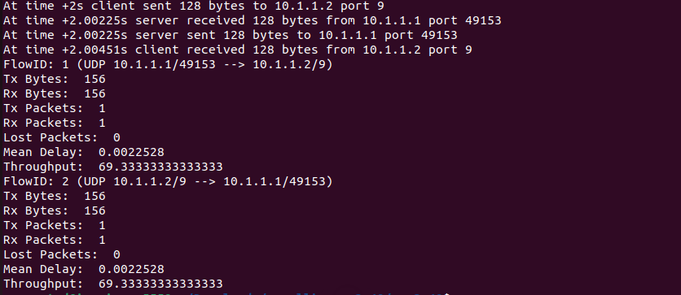

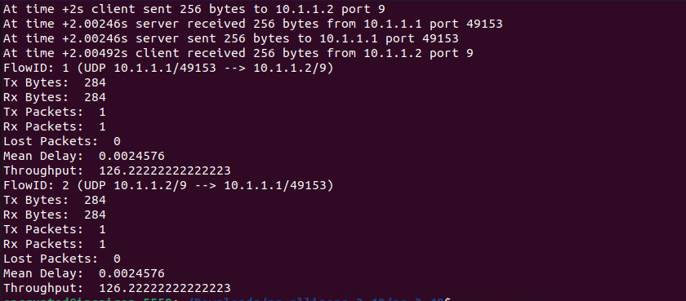

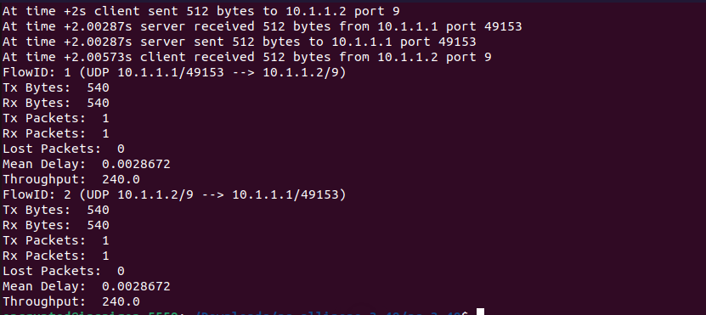

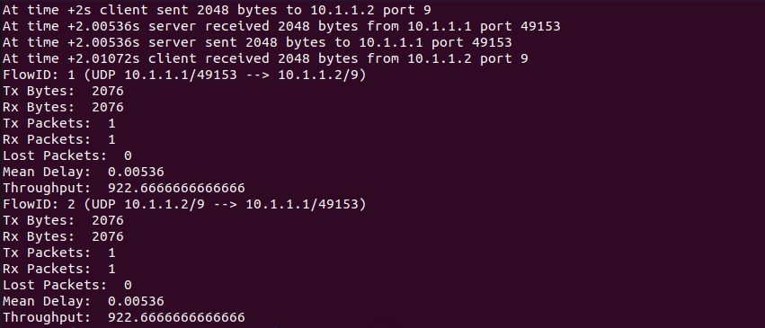

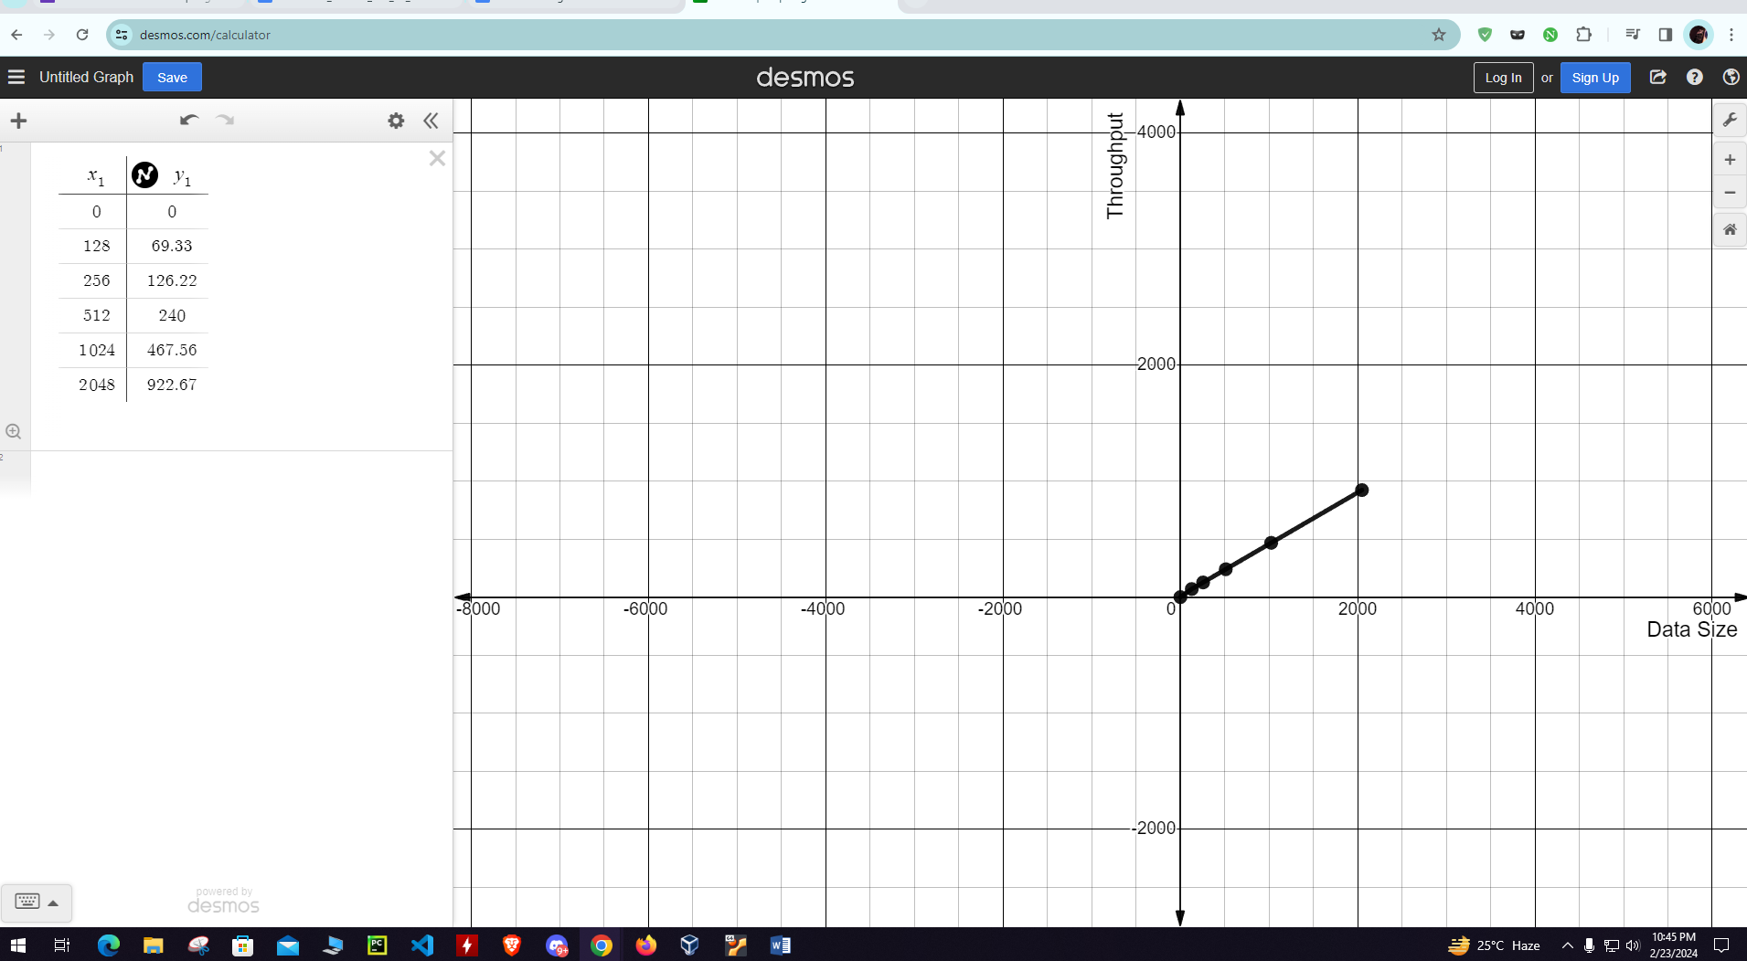

**Graph Description:**

The speed at which the network can transfer information is largely dependent on the amount of the data. The rate at which data may be handled increases in tandem with its size, from 128 bytes to 2048 bytes. This approach shows that more efficient transmission of larger data units is possible at a faster speed. As a result, a graph showing this relationship would show that throughput values increase as data sizes increase, with the y-axis representing throughput and the x-axis representing data size.